COURSE: CLOUD AND NETWORK SECURITY _C1-2024

STUDENT NAME: LENNIE NTHIGA
STUDENT NO: cs-cns07-24170
SEPTEMBER 18,2024

WEEK 1 ASSIGNMENT 2
CLASS EXERCISE: EXAMINE TCP/IP AND OSI MODELS IN ACTION

INTRODUCTION

This activity is meant for one to get farmiliar with different protocols being captured in a network both local network and remote hosts. Wireshark has feature of filtering the protocols for ease in analysing of the packets .in this case we would be pinging a device in the same network and web address to get to analyse their packets. We are to get to know what are some of the differences the similar outcomes and what new can be observed from wire sharks capture.

Part 1
We are going to ping the Ip address of a device which is in the same network
After getting the 2nd computer Ip address we would run cmd and ping it as
Ping 192.168.0.102
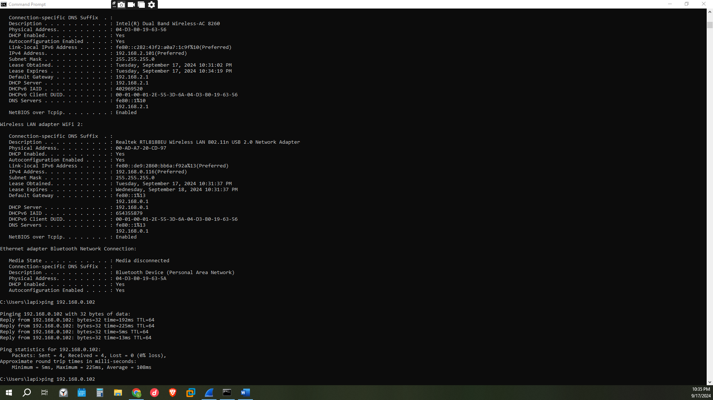

b. With this PDU frame still selected in the top section, navigate to the middle section. Click the plus sign to the left of the Ethernet II row to view the destination and source MAC addresses.
Questions:
Does the source MAC address match your PC interface? 00:ad: a7:20:cd:97
Does the destination MAC address in Wireshark match your team member MAC address? 36:ac: 72:41:08: d7
How is the MAC address of the pinged PC obtained by your PC?
My pc using Wireshark gets the mac address of the 2nd pc using arp.in which an Arp request would be send to the network asking who is the one owning the Ip and asks for a respond to be sent with their mac address this packet would be sent through the Ethernet using an Ethernet frame containing the source and destination mac address as the response
Icmp results with the source mac address

Resulting to the below pdu information of icmp (ping)
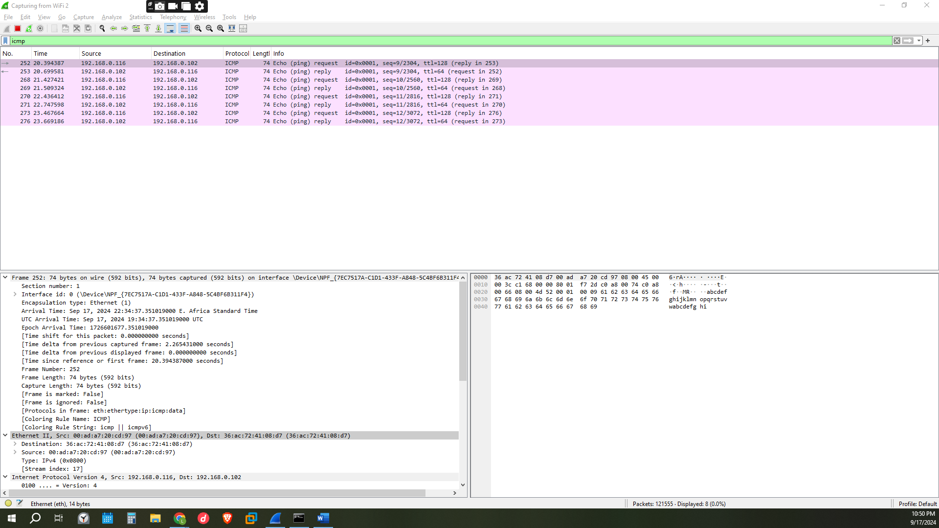
Pinging in icmp works by the icmp sending an icmp echo request to the network from the source to the destination Ip address however, the packet would be encapsulated in two forms ip packet which has the source and destination ips and protocols and further encapsulated in link layer frame which should have the source and destination mac address however the destination mac address is unknown and sent. If the destination mac address is not sending the hosts Arp cache the Arp broadcasts to resolve the mac address by asking the connected devices of the owner of the Ip address of the destination the Arp replies with the mac address correctly, the icmp receives the packets and generates the icmp reply with the mac address of the source and destination and source and destination Ip address

Part 2: Capture and Analyse Remote ICMP Data in Wireshark
Step 1
When pinging the domain names, we would find their Ip addresses on wire shark as the destination Ip address from the icmp captured packets as follows

- www.yahoo.com
its Ip address can be identified by identifying the pcs Ip address in which here it is the destination Ip address thus the source ip188.125.88.204 is the domains Ip thus the source mac address d8:32:14: b1:af:88 is the domains mac address however, note the mac address of this remote hosts/domains are not the actual mac address for one to get the actual mac address they must be in the same local network
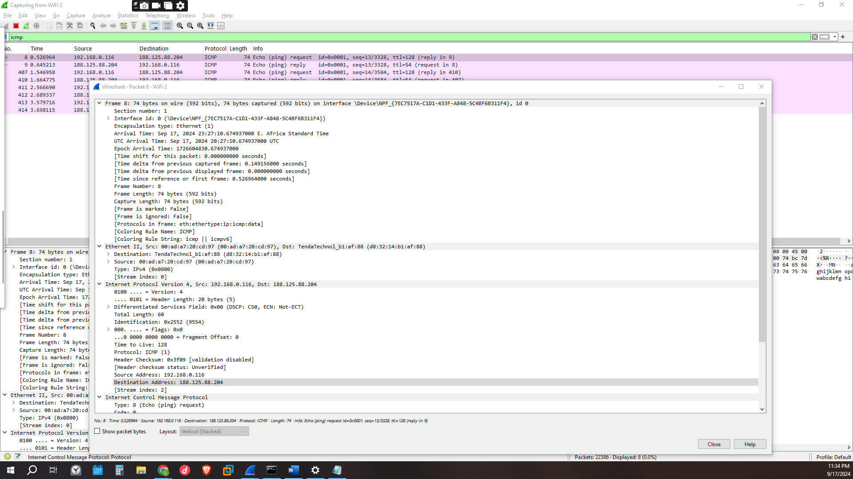
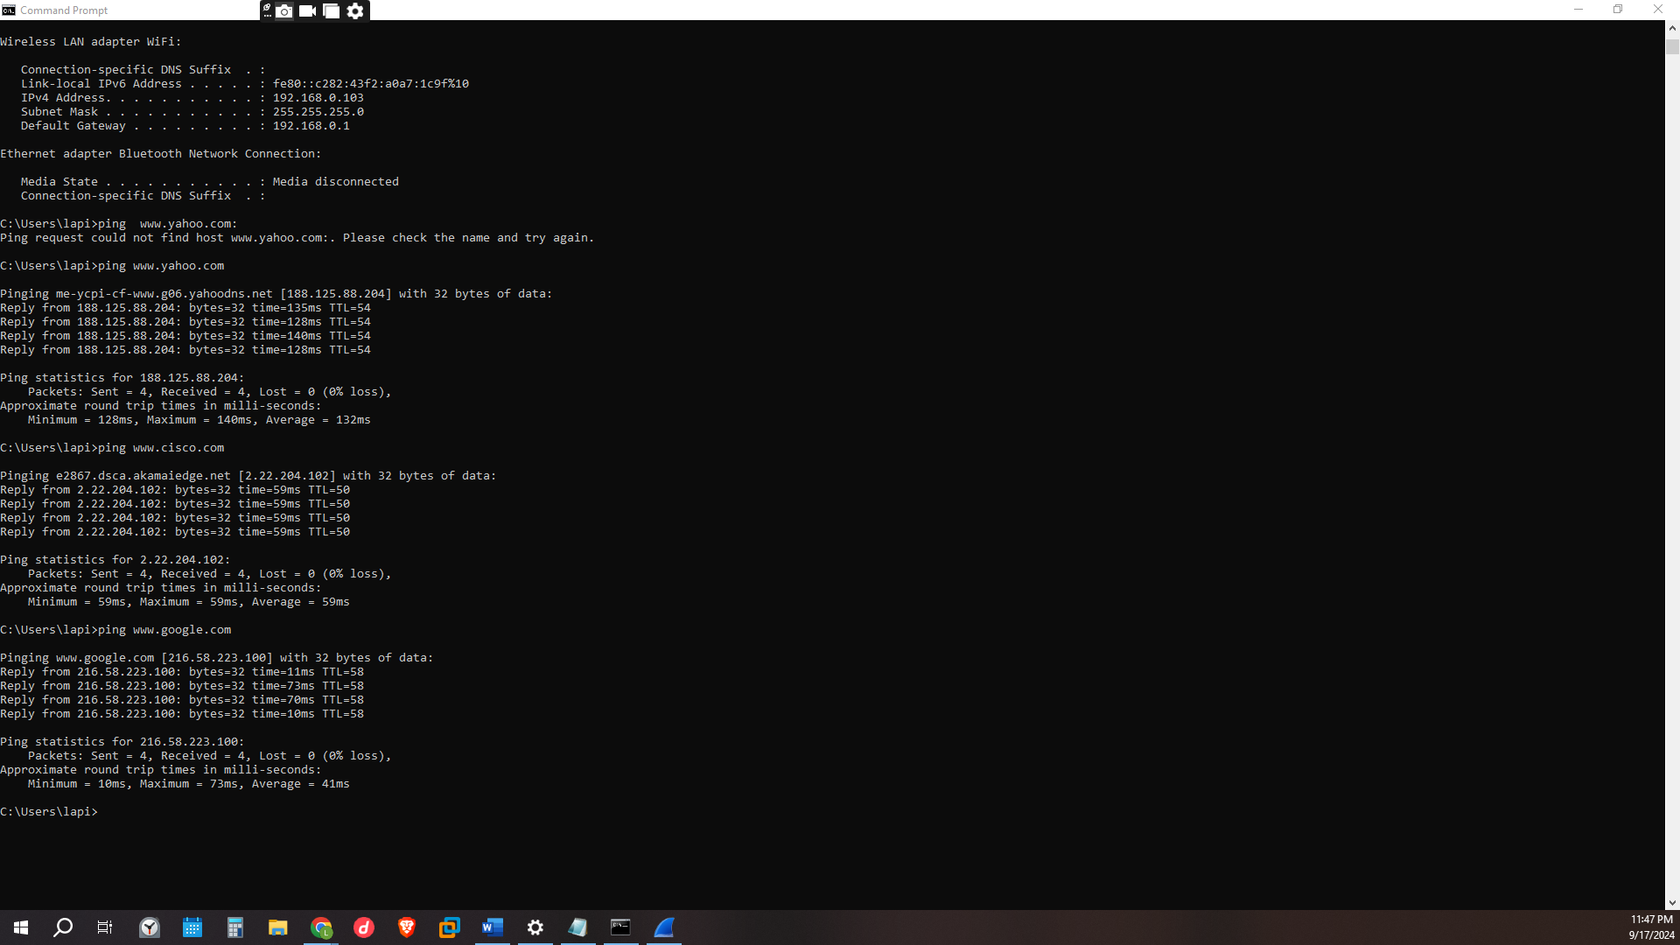
For the pinged addresses the below displays the captured packets on all three in which we can also find the mac address of the three address as
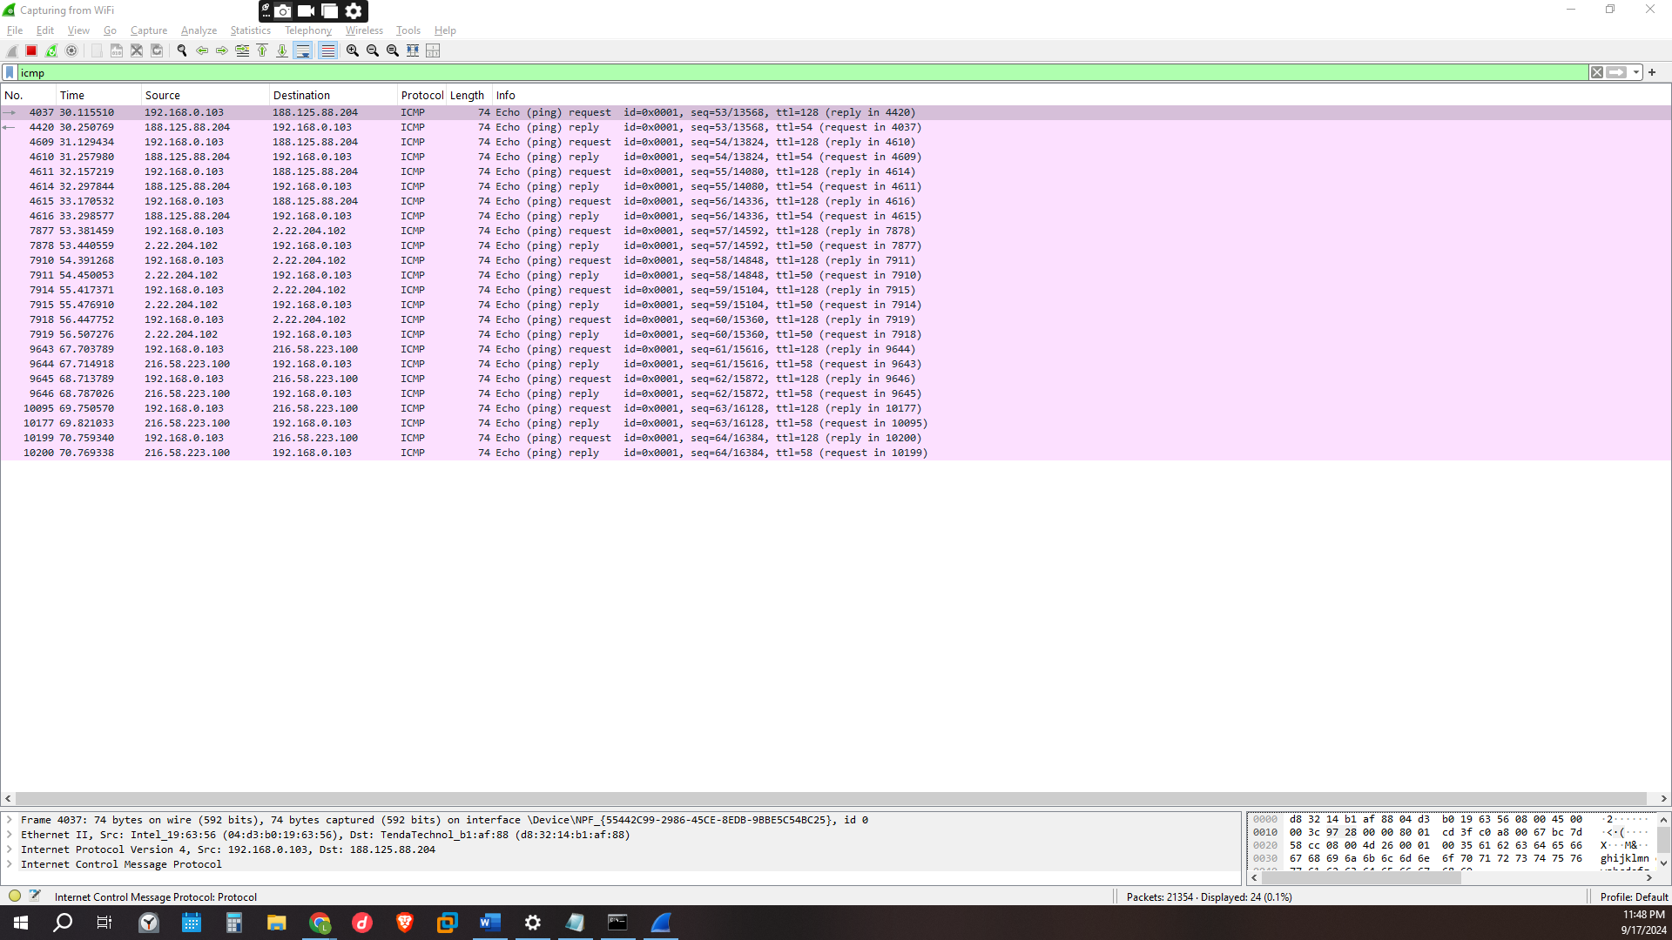
2) www.cisco.com
The Ip address can also be found on cmd after pinging the web address that is
Ping www.ciso.com one would find the reply as 2.22.204.102
Its mac address being= d8:32:14: b1:af:88
You can identify it by looking at its Ip address is displayed as source Ip address meaning this is a reply packet so the source mac address is the addresses mac address
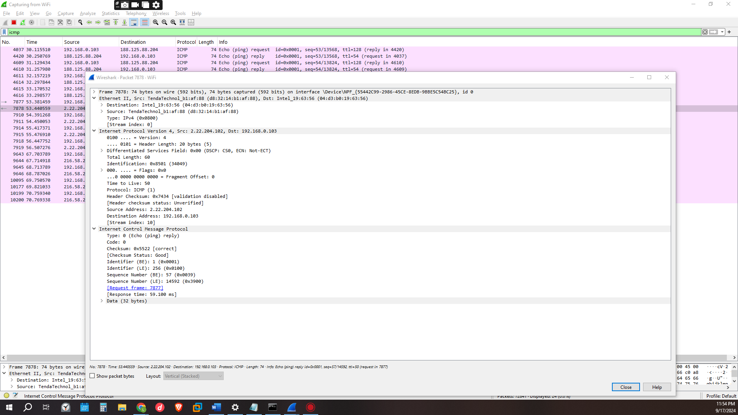

3) www.google.com Ip address=216.58.223.100
While its mac address is d8:32:14: b1:af:88
Here the destination Ip address is 216.58.223.100 thus the destinations mac address is the domains mac address d8:32:14: b1:af:88
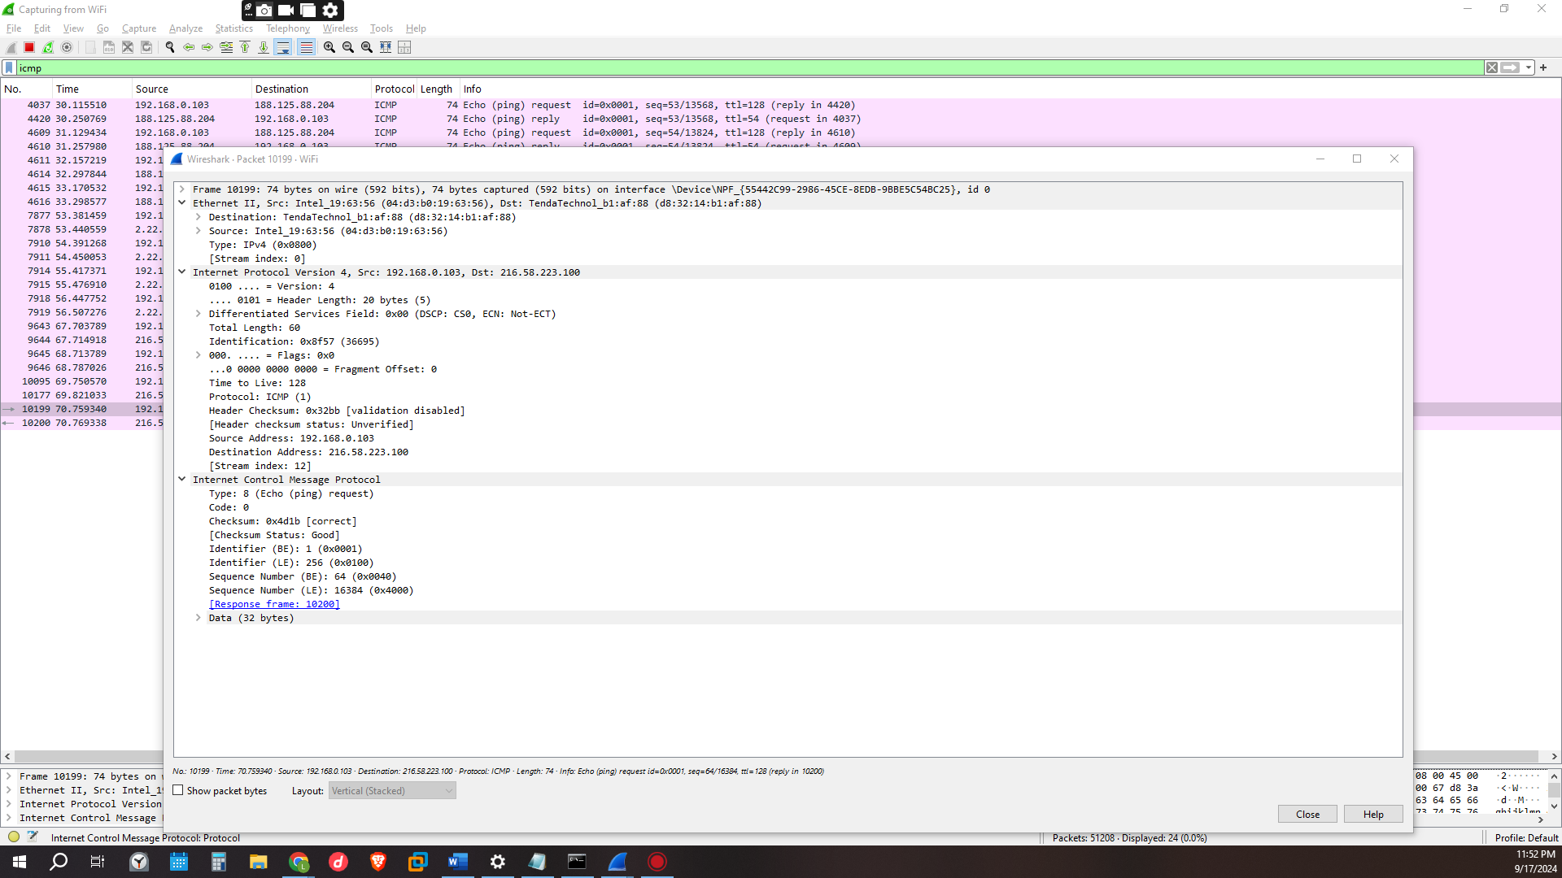

CONCLUSION
From this activity using Wireshark ones able to see how dons resolve the finding of domains Ip address. The aspect of a local network devices can retrieve each though mac address as to remote hosts using icmp is an aspect that one can use to test the ability of their computers network in troubleshooting. However, I can say that having an identified device in a network can lead to compromise if the firewalls aren’t effective from the amount of data that can be retrieved.

